

6/1/2016

Science and Engineering

Curtin University

HOOLI XYZ

Connor Beardsmore – 15504319

Brendan Lally – 18407220

Adam Brown – 18338993

Jordan Chou – 18348691

Edward Lim - 18339145

Final Report

Project Design and Management 300

# Abstract

This report has been generated to cover all aspects of the development of an online web platform for Curtin associates to collaborate on ideas and innovations. The report has been developed for the project client to address the key aspects of the project implementation, design and other project management issues. Outlined in this report is the project background, design and implementation decisions, full documentation for each Sprint iteration and a post-mortem discussion on the challenges faced.

The online platform was developed utilizing the Django framework, a high-level python web framework. Issue tracking was performed via the Pivotal Tracker platform, with version control also being applied as required. The back-end database of the platform was implemented via the SQLite database management system.

The project utilized Agile techniques and the SCRUM framework to ensure its success. SCRUM uses an iterative and incremental delivery solution to help deliver projects on track with all functionality implemented. The use of SCRUM ensured that the project was a success and that the team functioned efficiently and productively. The resulting solution delivered provides all the functionality requested by the project client in the requirements document. In addition to the functionality, the produced platform is fully polished with an easy to use and aesthetic user interface.

Table of Contents

Abstract 1

1.0 Introduction and Objectives 1

2.0 Background 2

2.1 Project Management Approach 2

2.2 Software Solutions Considered 2

2.3 Tools Utilized 2

2.4 Project Mockup 3

3.0 Product Backlog 5

3.1 Account 5

3.2 Administration 5

3.3 Commenting 6

3.4 Posting Submissions 6

3.5 Viewing Submissions 7

3.6 Voting 7

3.7 Rewards 7

3.8 Pivotal Tracker Analytics 8

4.0 Overall Design 10

4.1 Design Details 10

4.1.1 Back-end 10

4.1.2 User Interface 12

4.2 Implementation Details 12

4.1.2 User Accounts 12

4.1.2 Administration 14

4.1.3 Submissions 14

4.1.4 Comments and Improvements 15

4.1.5 Voting 16

4.1.6 Rewards 16

5.0 Project Review 18

5.1 What Went Right 18

5.2 What Went Wrong 19

5.3 What Was Learned 19

5.4 Future Improvements 20

6.0 Conclusions and Summary 22

7.0 References 23

8.0 Appendices 24

8.1 Appendix A: Sprint Reports 24

8.2 Appendix B: Pivotal Tracker Backlog 24

Table of Figures

Figure 1: Project Mockup 5

Figure 2: Cumulative Flow 9

Figure 3: Project Burnup 10

Figure 4: Project Burndown 10

Figure 5: Curtin Ideas Logo 12

Figure 6: Version Control Commits 13

# Introduction and Objectives

The main purpose of this report is to illustrate the process employed in developing our project solution for the Curtin Ideas platform. The report provides a detailed overview of the projects design and exists to summarize the teams progress over the previous four months. The primary audience of this report is the project client, in addition to anybody interested in understanding the SCRUM framework and its implementation on an academic group project.

The objective of the project was to deliver a working solution for the Curtin Ideas online platform. That is, a solution that has completely implemented all functionality defined by the project requirements. A secondary objective was for all team members to gain experience with both web development and the SCRUM agile development technique.

The project was heavily constrained by stringent time requirements and cost, as there was no budget at all allocate for the platform.

scope, delimitations

Approach used to complete work

Structure of report

# Background

## Project Management Approach

Scrum, agile etc etc

## 2.2 Software Solutions Considered

solution approaches considered, other similar systems, possible solutions looked at.

## 2.3 Tools Utilized

The tools considered for use throughout the project were centered around the following various categories:

* Communication
* Task management
* Development
* Documentation.

The tools considered for communication included *Facebook Messenger* and *Slack* for group messaging in addition to *Hangouts* and *Skype* for video conferencing. Due to some group members being unfamiliar with *Slack* we decided to go with the more familiar messaging platform and hence selected *Facebook Messenge*r. As for the video conferencing solution, we discovered that Skype required premium access for group video calls. As a result of this, we found that Skype did not fit our usage requirements. On the other hand, *Google Hangouts* is a free service provided by Google and is easily accessible. Both of the choices we made regarding communication tools are cross-platform and worked well with our group as members used a variety of devices from Android to iOS.

Utilizing Facebook Messenger allowed us to stay in contact with each other throughout the project duration. The push-notifications allowed members to quickly respond to questions which increased our productivity and helped reduce stress as we were able to stay up to date during the development process. The usage of Google Hangouts also increased productivity greatly. Our primary use for Google Hangouts was as an informal conferencing tool. We found that, due to the tools we have chosen and the way we allocated tasks, some members did not know how to do some things that others knew how to. When such a situation occurred we found that using Hangouts as a way to explain step-by-step worked well. The ability to share-screen in Hangouts made it an excellent learning tool and allowed more knowledgeable group members to guide and teach others.

Tools considered for task management were chosen to be suited for use with the SCRUM methodology. Software solutions considered included *Atlassian’s JIRA, Pivotal Lab’s Pivotal Tracker* and *Trello*. The group began to use JIRA but discovered that the student trial was not sufficient for the project. As the project owner had given us access to *Pivotal Lab’s Pivotal Tracker* we decided to use that platform as an alternative. However, the group found *Pivotal Tracker* a little cumbersome to use over time and we decided to additionally use *Trello* to track the tasks.

The decision on which tools to employ for the actual development of the platform was crucial to the success of the project as a whole. The tools we considered included *PHP, C# ASP.NET, Django,* and *Node.js*. Database management solutions that we considered *included MongoDB, MySQL, phpMyAdmin and sqlite3*. The majority of team members had no prior experience in web development so no matter the choice we had a large learning curve to overcome. After researching online, we opted for *sqlite3*, the simplest of the database tools. In order to connect to our database, perform business login and serve the frontend we decided to develop the platform using the *Django* framework, due to its relatively simple learning curve. Several group members desired to learn *Python* and hence *Django* also provided this benefit. Both the *Django* framework and *sqlite3* systems are open source, ensuring that no additional cost is passed onto the project client.

## 2.4 Project Mockup

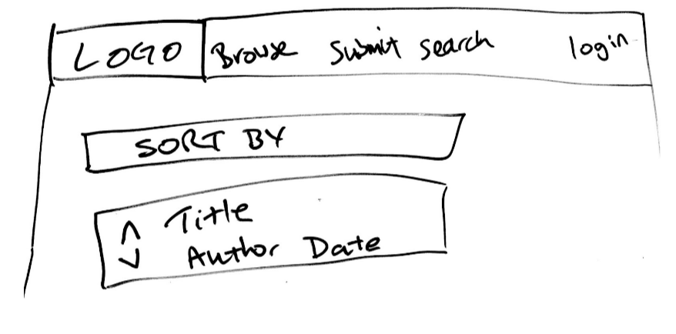

Figure 1: Project Mockup

# Product Backlog

Upon receiving the project requirements from the client, the requirements were converted into a collection of 45 user stories. These stories were further broken down into groupings for simplicity and to improve modulation when the stories were implemented. The following major groupings were applied to the user stories:

* Account
* Administration
* Commenting
* Posting Submissions
* Viewing Submissions
* Voting
* Rewards

Each user story was allocated into a specific grouping, with each Sprint generally focusing on completing one or two groups of stories. The group allocations for all user stories are displayed below. For a more detailed overview of the product backlog and a breakdown of stories completed per sprint, see the attached file exported from *Pivotal Tracker* in Appendix B.

## 3.1 Account

* As a User, I want to login to the platform so that I can post a submission.
* As a User, I want to logout of my account so that nobody else can access my account.
* As a User, I want to create an account so that I can use the platform.
* As a User, I want to be able to change my password so that I can keep my account secure.
* As a User, I want to access user profile so that I can view specific user’s details.

## 3.2 Administration

* As an Admin, I want access to a Admin platform so that I can perform administrative actions.
* As an Admin, I want to create user profiles so that users can use my site effectively.
* As an Admin, I want to edit submissions so that I can remove offensive language.
* As an Admin, I want to remove submissions so that I can remove inappropriate submissions
* As an Admin, I want an Admin tag so that other Users see my account as an Admin.

## 3.3 Commenting

* As a User, I want to delete my improvements so that I can remove my improvement.
* As a User, I want to edit my improvements so that I can fix spelling errors.
* As a User, I want to delete my comments so that I can remove my comment.
* As a User, I want to edit my comments so that I can fix spelling errors.
* As a User, I want to suggest improvements to a submission so that I can improve upon an idea.
* As a User, I want to comment on a submission so that I can voice my support of the idea.
* As an Admin, I want to be able to delete comments because they may contain inappropriate material.
* As an Admin, I want to edit comments so that I can remove offensive language.
* As an Admin, I want to delete improvements so that I can remove inappropriate improvements.

## 3.4 Posting Submissions

* As a User, I want to post a submission so that I can put my idea onto the platform.
* As a User, I want to delete my submission so that I can remove my submission.
* As a User, I want to edit my submission so that I can fix spelling errors.
* As a User, I want to add images to my submission so that I can add relevant images to my submission.
* As a User, I want to add videos to my submission so that I can add relevant videos to my submission.

## 3.5 Viewing Submissions

* As a User, I want to view existing submissions so that I can see all submissions posted.
* As a User, I want to search all submissions so that I can find one relevant to my field of study.
* As a User, I want to sort submissions based on popularity so that I can see the most popular submissions.
* As a User, I want to sort submissions based on date so that I can see the newest submissions.
* As a User, I want to sort submissions based on views so that I can see the most popular submissions.
* As a User, I want to categorize my submissions so that other users can find it easily.
* As a User, I want to view submissions based on category so that I can view relevant submissions.

## 3.6 Voting

* As a User, I want to down-vote on submissions so that I can acknowledge submissions I dislike.
* As a User, I want to up-vote on submissions so that I can support submissions I like.
* As a User, I want to see the total votes for a submission so that I can see how popular it is.
* As a User, I want to up-vote on improvements so that I can support improvements I like.
* As a User, I want to down-vote on improvements so that I can acknowledge improvements I dislike.
* As a User, I want to only vote once for a submission so that voting is fair and equal for all users.
* As a User, I want to un-vote on submissions so that I can change my mind on voting.

## 3.7 Rewards

* As a User, I want other users to see my level when I post so that I can show off my level.
* As a User, I want to gain levels based on my points so that I am rewarded for utilizing the platform.
* As a User, I want to gain points when my submission receives votes so that I am rewarded for good work.
* As a User, I want to gain points for posting improvements so that I am encouraged to post again.
* As a User, I want to gain points for posting submissions so that I am encouraged to post again.
* As a User, I want to gain points for voting on submissions so that I am encourages to vote again.

## 3.8 Pivotal Tracker Analytics

The following figures illustrate the progress through the product backlog over the period of the project. Figure 2 shows the cumulative flow of points, while Figure 3 and Figure 4 display the project burnup and burndown respectively.

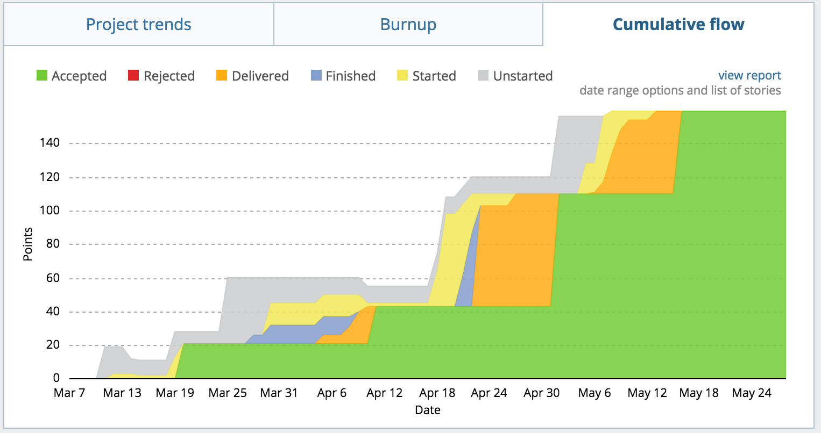

Figure 2: Cumulative Flow

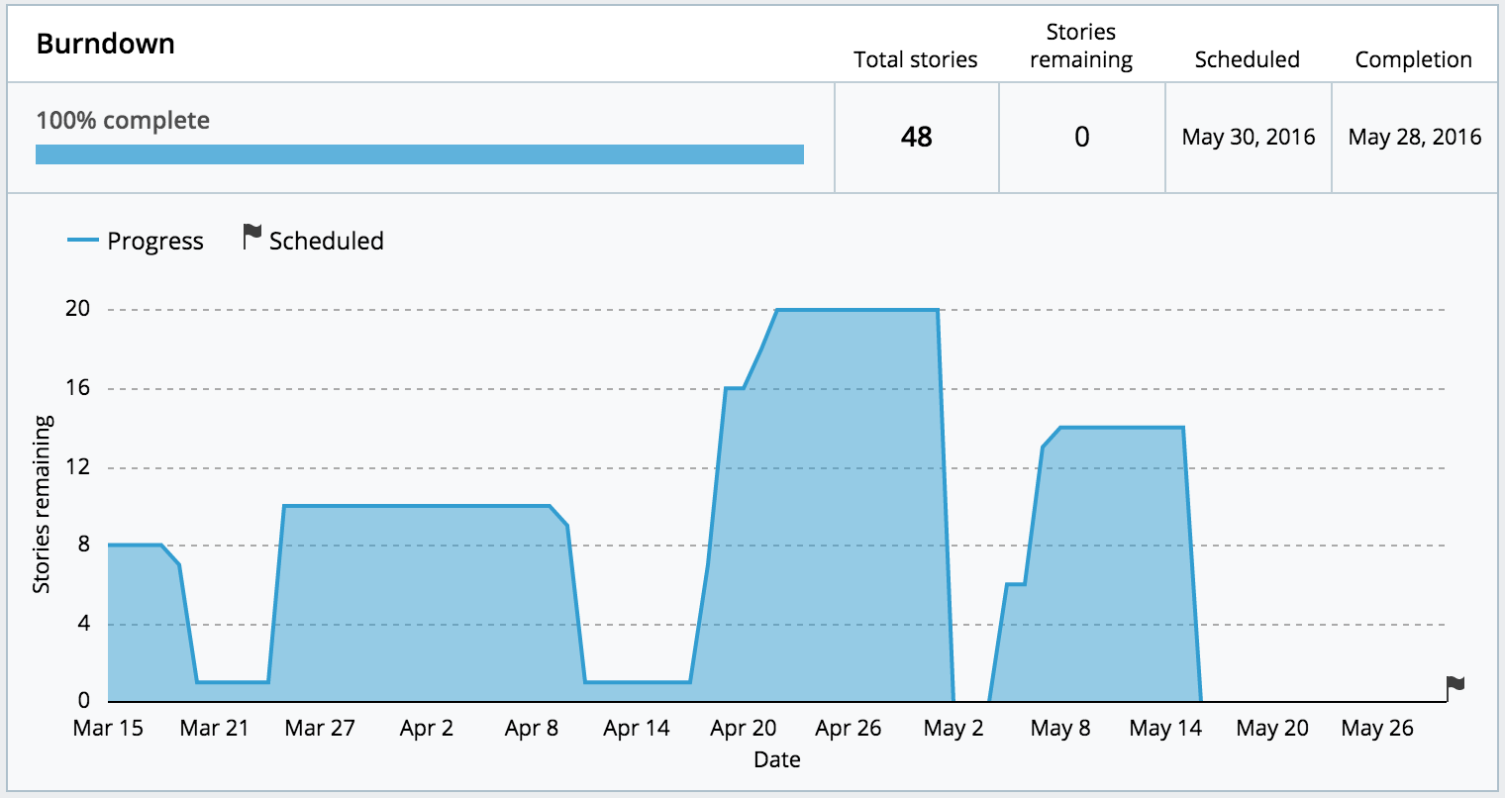

Figure 4: Project Burndown

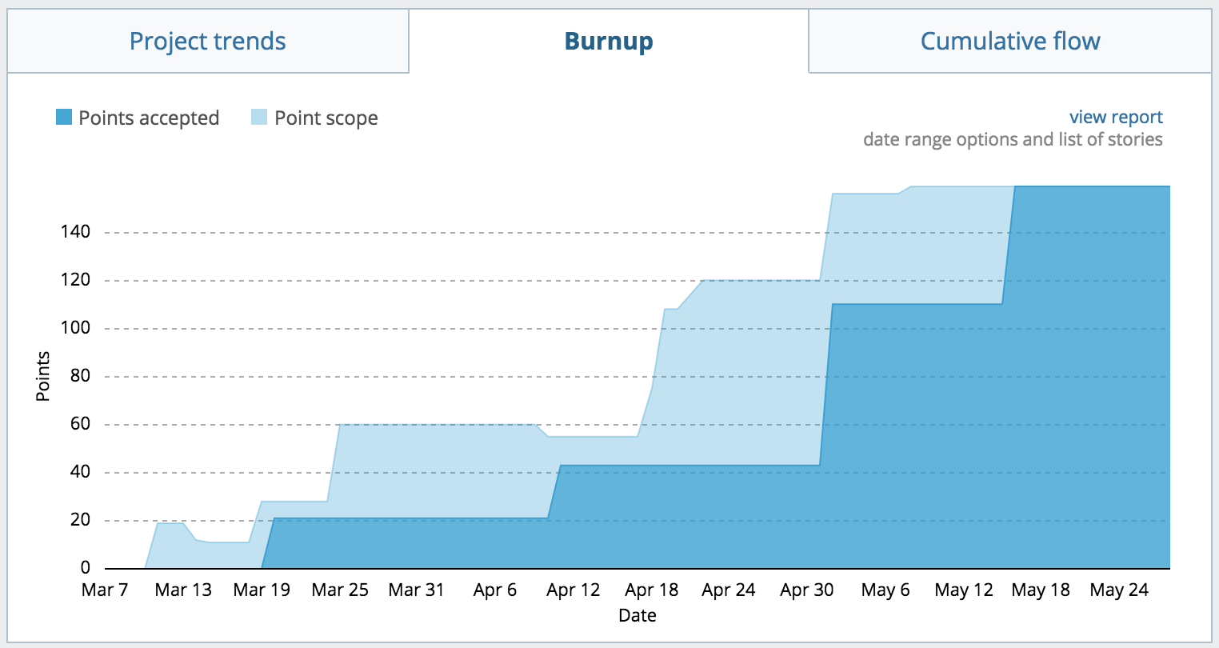

Figure 3: Project Burnup

# Overall Design

This section of the report illustrates the overall design details and details of the implementation of the platform. The design details consider both the back-end and front-end user interface while the implementation details cover all of the user story groupings discussed in the product backlog.

## 4.1 Design Details

As mentioned within the report background, it was decided that the platform would be implemented using the Django web framework. This would allow for easy-to-use and powerful admin features, along with well-defined methods to implement all the functionality deemed necessary. Django’s model system seemed very applicable for creating objects such as users, submissions and comments which were central to the overall design. An overview of all the models utilized in the back-end system is illustrated in Figure 5.

### 4.1.1 Back-end

One of the major design issues that was central to the project as a whole was the idea of the submission. The submission model needed to store information about a user-generated idea including the title, author, category, the idea itself and links to external webpages. Every feature of the platform in some way interacts with the submission, be that viewing the submissions or suggesting improvements for it. Additionally, submissions had to be both editable and removable by the correctly privileged users/admin.

We wanted a user to be able to create an account, storing basic personal information that could be used to identify the user. We also desired a user to be able to participate in posting submissions and both commenting and voting on them. The choice was made that a user would have to be currently logged onto the system to be able to submit, comment and vote on any submissions. However, submissions could be viewed by anyone of the general public without requiring a registered account, as requested by the project client.

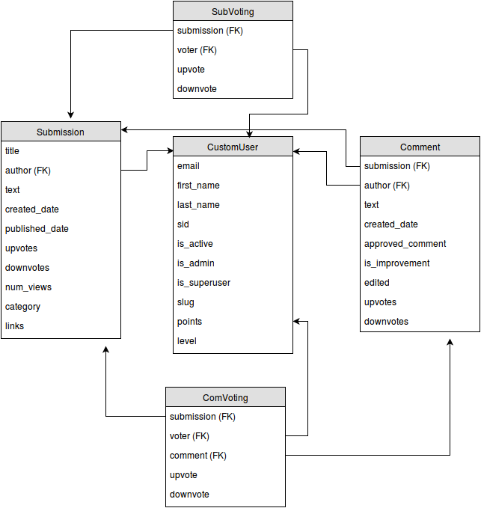

Figure 2: Django Models Overview

Comments and improvements were added for users to be able to give and receive feedback on ideas that were submitted. This feature fits with the whole collaborative ideology of the platform. Improvements enhanced the idea of comments, allowing users to provide constructive criticism on how to improve a submitted idea.

### 4.1.2 User Interface

The user interface design went through numerous iterations before eventually settling on the final design. The main aims of the interface design were to create a sleek, modern and polished interface. This interface was required to be both easy to use and easy to navigate to ensure users enjoyed utilizing the platform.

## 4.2 Implementation Details

As discussed previously, all user stories were categorized into different groupings. The task of implementing the stories within these groupings were distributed to different group members, typically in pairs. A Fibonacci points system was used to estimate the effort required to complete the tasks. An effort of 1 or 2 typically meant the task was fairly straightforward to implement. An effort of 3 meant that more time was required and some research had to be undertaken to successfully implement the task. The 5 effort rating was the maximum effort estimation used in the project, implying that the feature required more thought and often multiple iterations to successfully implement.

Over the life of the project, there were minimal changes to the account creation form and overall functionality, with only a few user interface improvements being added later on. All of the planned functionality from the user stories was successfully implemented by the date of final release. Each of the user story groupings had specific implementation details.

### 4.1.2 User Accounts

The initial plan was to implement the administration and basic user account functionality to form the underlying framework of the project. The tasks required to set up user accounts included: creating a user model which in Django is used to represent a database object with object fields, creating a login form for users to enter the required personal information and adding logout and password changing capabilities. These tasks were given effort ratings of 2 and 3. An account creation form was made to allow the user to input the required information such as name, email, student/staff id and password (Figure 6). All the remaining information required by the system is automatically added to the created user object which is then stored in the back-end database.

Another feature relating to user accounts was the ability to display each user’s profile information in a user profile (Figure 6). The task breakdown for adding the user profile included: creating a template to display the relevant user information, adding a progress bar to track points and linking these attributes to the database to allow them to be dynamically updated. The overall effort estimation for the profile implementation was 5.

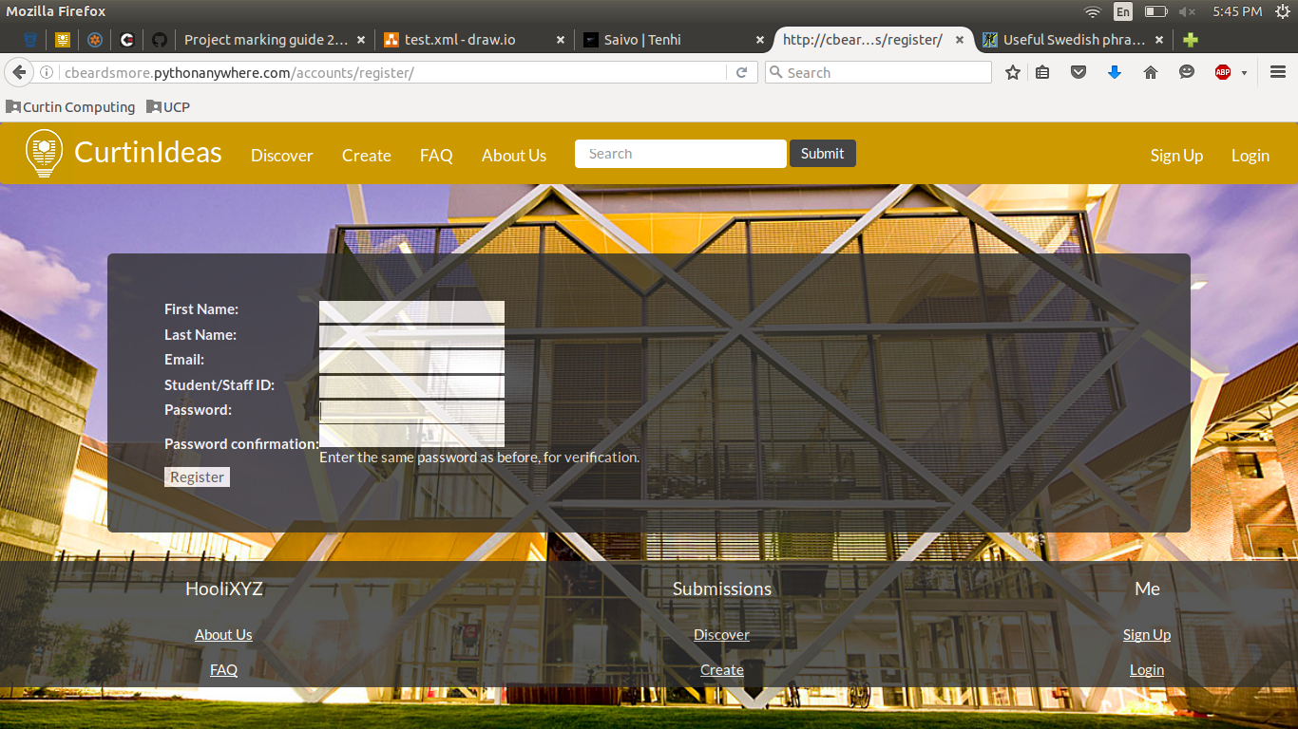

Figure 3: User Creation Form

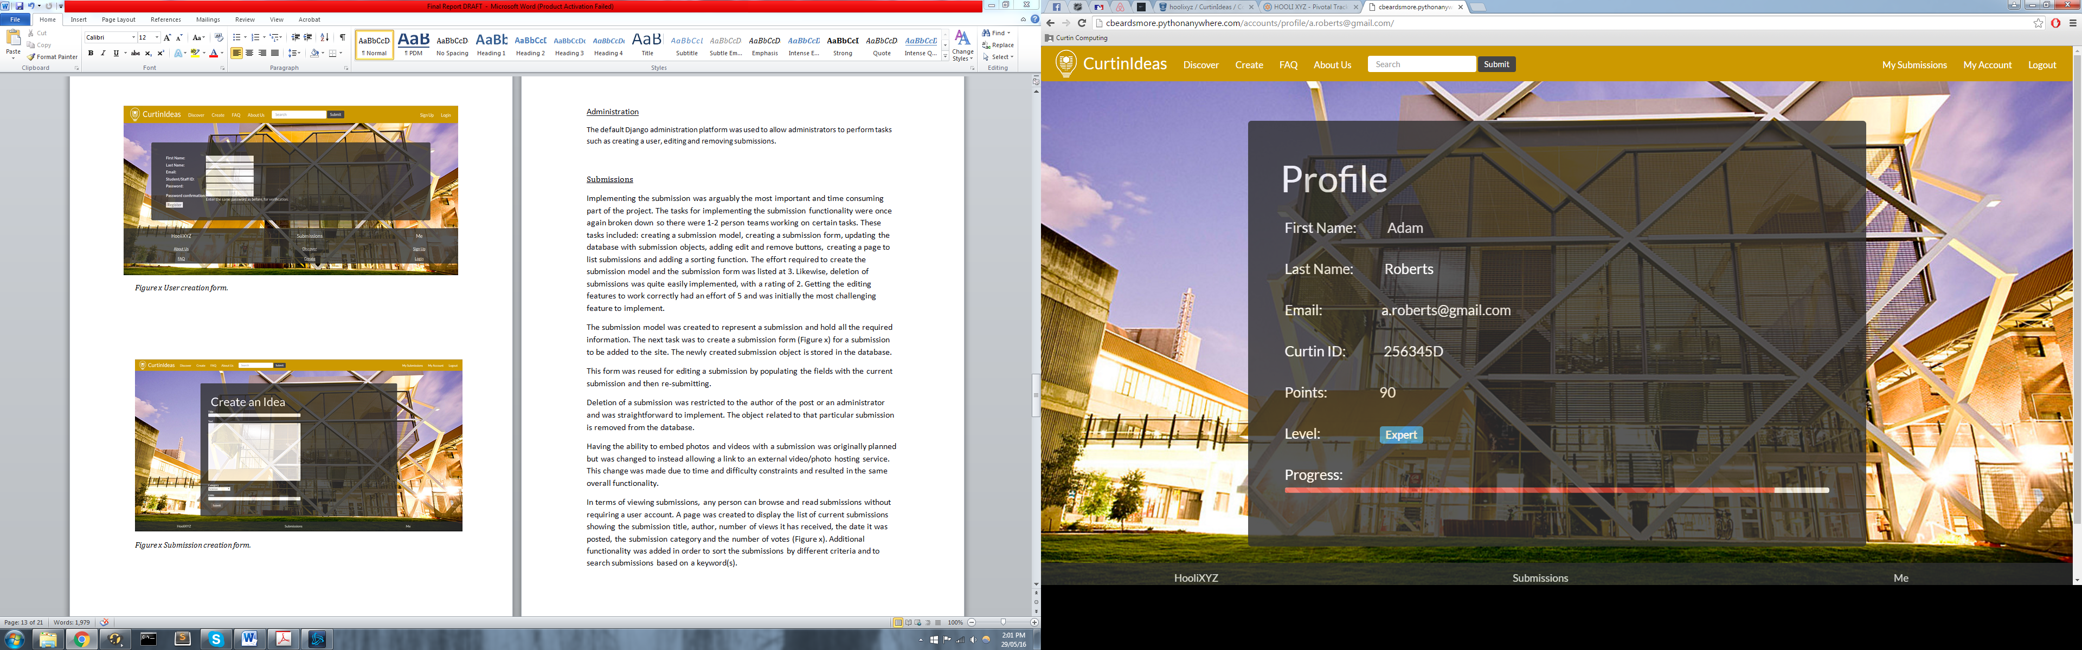

Figure 4: User Profile Display

### 4.1.2 Administration

The default Django administration platform was used to allow administrators to perform tasks such as creating a user, editing and removing submissions. This platform is in-built into the Django framework and little work was required to integrate this functionality seamlessly into our platform.

### 4.1.3 Submissions

Implementing the submission was arguably the most imperative and time consuming portion of the project. The tasks for implementing the submission functionality were once again broken down so there were separate pairs working on certain tasks. These tasks included: creating a submission model, creating a submission form, updating the database with submission objects, adding edit and remove buttons, creating a page to list submissions and adding a sorting function. The effort required to create the submission model and the submission form was listed at 3. Likewise, deletion of submissions was quite easily implemented, with a rating of 2. The task of implementing the editing features to work appropriately received an effort rating of 5 and was initially the most challenging feature to implement.

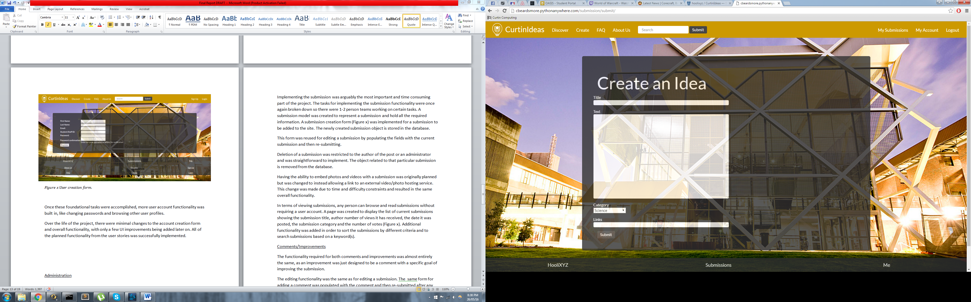

Figure 5: Create Submission Form

The submission model was created to represent a submission, holding all the required information in the database. The subsequent task was to develop a submission form (Figure 6) for a submission to be added to the platform. This form was reused for editing a submission by populating the fields with the current submission and then re-submitting, reducing the amount of duplicate work performed.

Deletion of a submission was restricted to the author of the post or an administrator and was straightforward to implement. The object related to that particular submission was simply removed from the database and the new submission page loaded.

Having the ability to embed photos and videos within a submission was originally planned but was modified after concerns about the time this would take. After deliberation with the project client, the decision was made to instead allow only links to images and videos instead of the embedded alternative. Despite this change, the overall functionality is not modified.

In terms of viewing submissions, any person can browse and read submissions without requiring a user account as requested by the client. A page was created to display the list of current submissions showing the submission title, author, number of views it has received, the date it was posted, the submission category and the number of votes (Figure 6). Additional functionality was added in order to sort the submissions by different criteria and to search submissions based on a keyword(s). Whilst this feature was easily implemented, it provided a large amount of functionality to the user.

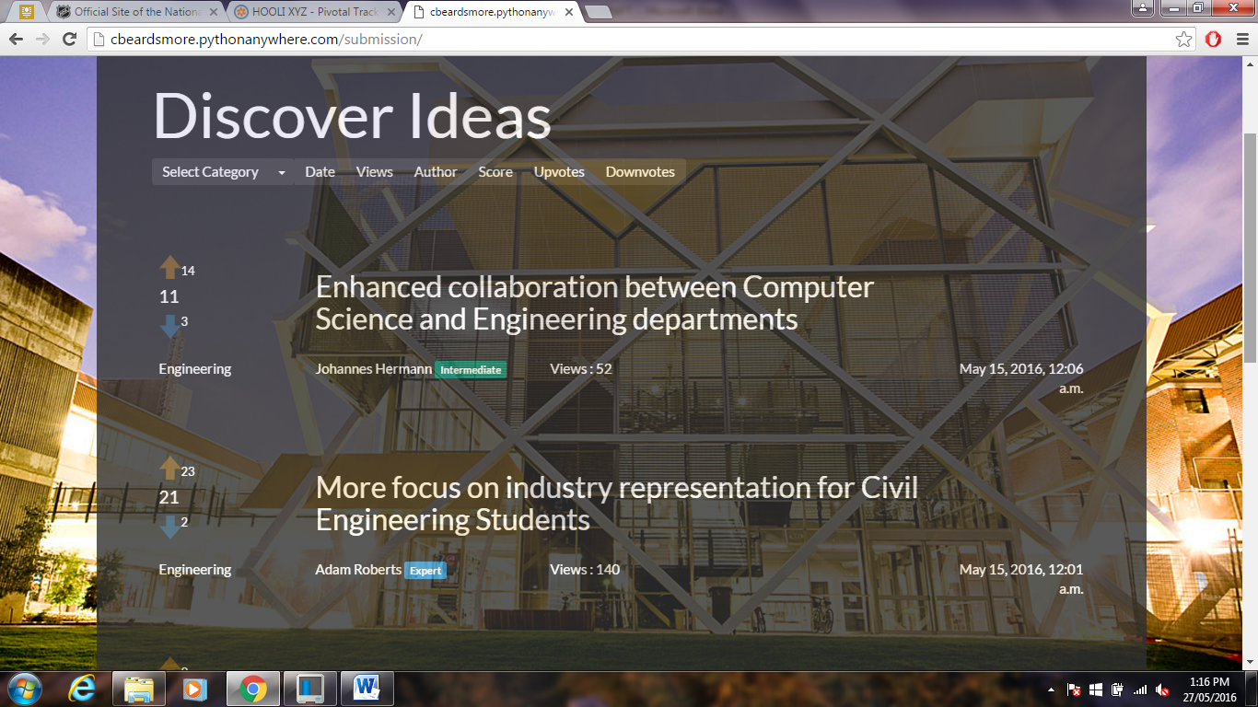

Figure 6: Submission Listing

### 4.1.4 Comments and Improvements

Each submission had the ability to receive comments and improvements from other student/staff users. The task breakdown for being able to add a comment included creating a comment model, creating a form to handle the comment input and linking the comment object to the target submission object. At this stage of the project, a lot of similar functionality had already been added for other sections and so the efforts given for the implementation reflected this, with generally 2 - 3 effort points. To declare whether a comment is also an improvement, a tick box was added to indicate if the user intends for their comment to be an improvement.

The editing and deleting functionality were the same as that for a editing and deleting a submission. The initial form used for adding a comment was populated with the original comment and then re-submitted after any edits were completed.

### 4.1.5 Voting

The voting functionality was implemented for both submissions and comments. The tasks that were assigned included: adding clickable arrow images to represent the up-voting and down-voting features (Figure x), adding and updating the overall vote total by subtracting the total down-votes from the total up-votes and greying out a user’s ability to vote multiple times on the same submission/comment. The effort estimation for the voting tasks varied from 2 and 3 for displaying/calculating the totals and the main functionality to a higher effort of 5 for only allowing a user to vote once per submission.

Voting was restricted to users with accounts and only one vote per user per submission/comment. Voting was initially implemented as two fields; up-vote and down-vote, in the submission and comment model before being moved to their own models, one for submission voting and one for comment voting. The decision to move the voting functionality to a separate model (CONNOR WHY??).

### 4.1.6 Rewards

The reward system was the final feature to be implemented after all the other features were completed and working. As previously discussed, the reward system was designed to ‘reward’ users for participating in the generation and discussion of ideas, whether by creating submissions or voting/commenting on other users submissions. The plan was to implement a points system to keep track of how active a user is by allocating points per submission, comment or vote. The allocation of points was set to 5 for posting a submission, 3 for commenting on a submission and 1 for voting on a submission (CHANGE THIS TO THE ACTUAL POINT SYSTEM). Initially, a user would start at the base level with 0 points and every 20 points gained, a new ‘level’ was reached. This was implemented by adding two extra fields to each user object to track their points and their current level.

ADD 1 PARAGRAPH ABOUT THE LEVELS

# Project Review

## 5.1 What Went Right

Numerous aspects of the project worked well for the group and contributed to the overall success of the project. Throughout all Sprints, the moral of the team was high and the work ethic of each team member was decent. Being able to choose our team members was a likely factor producing this, with everyone in the team already knowing each other relatively well before the start of the project.

The aspect that helped the most in the product development was the high level of communication between all team members. Every member attended the weekly SCRUM meetings that were held and these worked to guide the team in completing their designated stories for each sprint. In addition to these formal meetings, communication was also performed via a *Facebook* group message. This allowed us to be in constant communication and ask for help or clarification instantly when it was required.

Another team-based part of the project that went well was the utilization of pair programming. Every story was allocated not to an individual, but to a pair of team members. This greatly enhanced performance as members could bounce ideas off one another and troubleshoot bugs and issues in tandem. As a result, this contributed to the high morale of the group and resulted in high all-round performance. This also resulted in no major issues arising in the weekly SCRUM meetings.

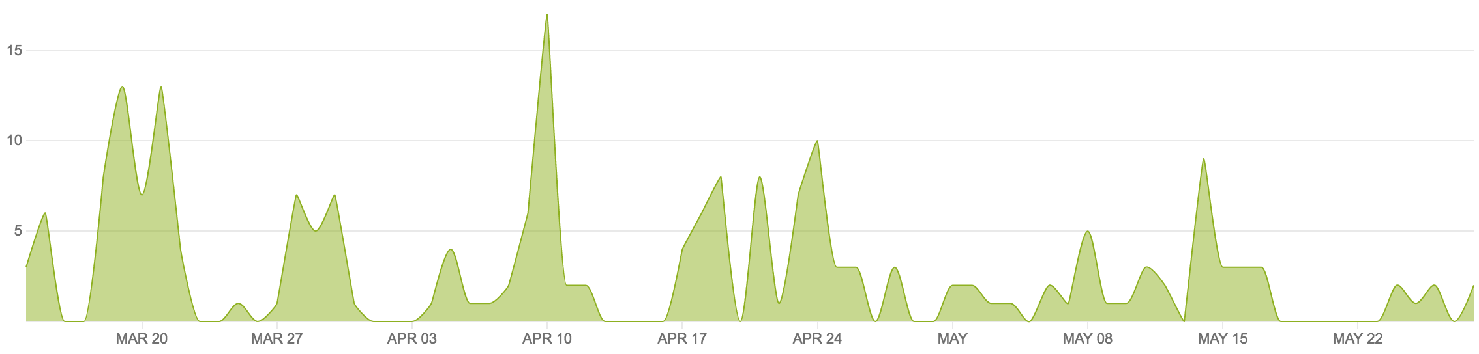

Figure 5: Version Control Commits

Numerous tools utilized throughout the project worked in our favor during product development. The use of version control via the *BitBucket* platform enabled team members to concurrently work on the project without their work interfering with one another. The commits pushed to this platform are shown in Figure 5 and analysis of this helps us to analyze our group and individual contributions over time. It also enabled us to rollback and help solve any regression errors inserted into the source code. The issue tracking tool *Pivotal Tracker* worked to keep the team on track and provide a metric on how our performance was progressing and whether we were on track or not. Without this, we expect we would not have fully implemented the solution by the final release date.

The final feature of the project that went well was the choice of web development tools employed. The use of the easy-to-learn Django web framework for the development platform meant that team members could learn the relevant skills to perform their required work with ease. It also enabled us to use the PythonAnywhere tool for hosting the site, providing users and the project client with easy access, comparatively to some other hosting solutions. All in all, the majority of aspects of the project went extremely well and the project smoothness as a result of this contributed strongly to our overall performance.

## 5.2 What Went Wrong

Despite the majority of aspects being productive during the project, some aspects of the project could have been performed better. The major issue was the team’s unfamiliarity with both the SCRUM process and web development projects in general. This project was the first undertaken for many of the team members and thus the learning curve was relatively steep. This was shown by our weak performance in Sprints one and two. Our team also had no experience with web development frameworks and thus learning these technologies slowed our progress significantly in the early weeks. This was unavoidable however and we believe we dealt well with this minor setback.

Not having undertaken any previous projects however also led to aspects of poor project management at times. The most significant of these would have been the poor time management shown occasionally. This become a concern at times when members had external time constraints and thus productivity was greatly reduced. The experience learned from these mistakes will be vital in future projects as we further enhance and hone our time management skills.

## 5.3 What Was Learned

The team has learned a lot from the project and grown significantly as a result. Coming into the project, the team had no experience with project management, web development or the Agile and SCRUM frameworks. Coming out of the project however, each team member now has a firm understanding of these concepts and experience in applying them to an actual concrete project.

The project management skills and time management skills learnt will be extremely useful in future projects. Learning how to balance productivity with external time constraints is a valuable skill that any member of a project requires and hence learning this skill has been very immensely valuable. The experience gained in general group skills cannot be quantified in a metric, but is also a good skill for each team member to have acquired.

Team members gained experience in several tools and frameworks during the semester. The use of version control was crucial to the success of this sprint and now each member understands how to apply it in future roles. Similarly, the team learnt how to use issue tracking software as a project management tool to ensure the project was kept on track and was an overall success.

The major point of learning throughout the project came in terms of web development. The team developed a full-stack web platform without any prior web development knowledge and thus, everything was learned during the project itself. The Django framework is now considerably understood by the team and can be applied in the future if ever required again. The python language has also been learnt to an extent and this tool will no doubt be of use in the future to all the software engineers involved.

## 5.4 Future Improvements

The group has several recommendations for future participations of the Project Design and Management unit. These are issues we discovered throughout our participation of the unit and may not be relevant to certain groups and their personal group-dynamic.

Firstly, the weighting of the project was weighted heavily towards the SCRUM process and the Sprint and Final reports. We propose placing some of this weighting into the platform and its actual functionality. Thus, teams that produce a fully working and functional solution can receive marks for this. As a team that completed all functionality, this would have benefitted us significantly.

During the project, the one-on-one time with the project client was extremely limited. Through Sprint 3, only a small 10-minute window was held with the client. We feel that more time with the project client to discuss specifics on aspects such as styling and functionality implementation would benefit both our team and the final solution. However, this may be difficult considering the time constraints of both parties and the constraints of a university unit in general.

# Conclusions and Summary

Brief summary

What was achieved in product development

What as gained in project experience

The following list produced indicates expansions and new features that can be implemented in future release of the product. The project client may wish to implement these recommendations into the platform over time to enhance the solution:

**Expansions:**

* Enhanced reward system with added rewards upon reaching certain levels
* Embedded images and videos for links in submissions
* Enhanced user profiles, enabling user to upload profile pictures and modify their details

**New Features:**

* Implementation of a scoreboard, listing the top 10 contributors for each category
* Department added to user profiles and on posting, to link users from departments
* Dynamic page background that change over time

# References

Grellier, Jane, and Veronica Goerke. 2010. *Communication Skills Toolkit*. 1st ed. South Melbourne, Vic.: Cengage Learning.

Park, Thomas. "Darkly." Bootswatch:. Accessed March 28, 2016.

https://bootswatch.com/darkly/.

"Pivotal Tracker | Agile Project Management". 2016. *Pivotal Tracker*. https://www.pivotaltracker.com.

Schwalbe, Kathy. *Information Technology Project Management.* 7th ed. Boston, MA:

Thomson Course Technology, 2006.

Twalib, Salim. *"Agile Lecture."* Class lecture, Project Design and Management from Curtin University, Perth, Australia, February 29th 2016.

# 8.0 Appendices

## 8.1 Appendix A: Sprint Reports

The full Sprint reports for sprints 1 through 4 have been included as an attachment to this final report.

## 8.2 Appendix B: Pivotal Tracker Backlog

All data tracked within the issue-tracking tool *Pivotal Tracker* has also been included as a *csv* attachment to this final report.